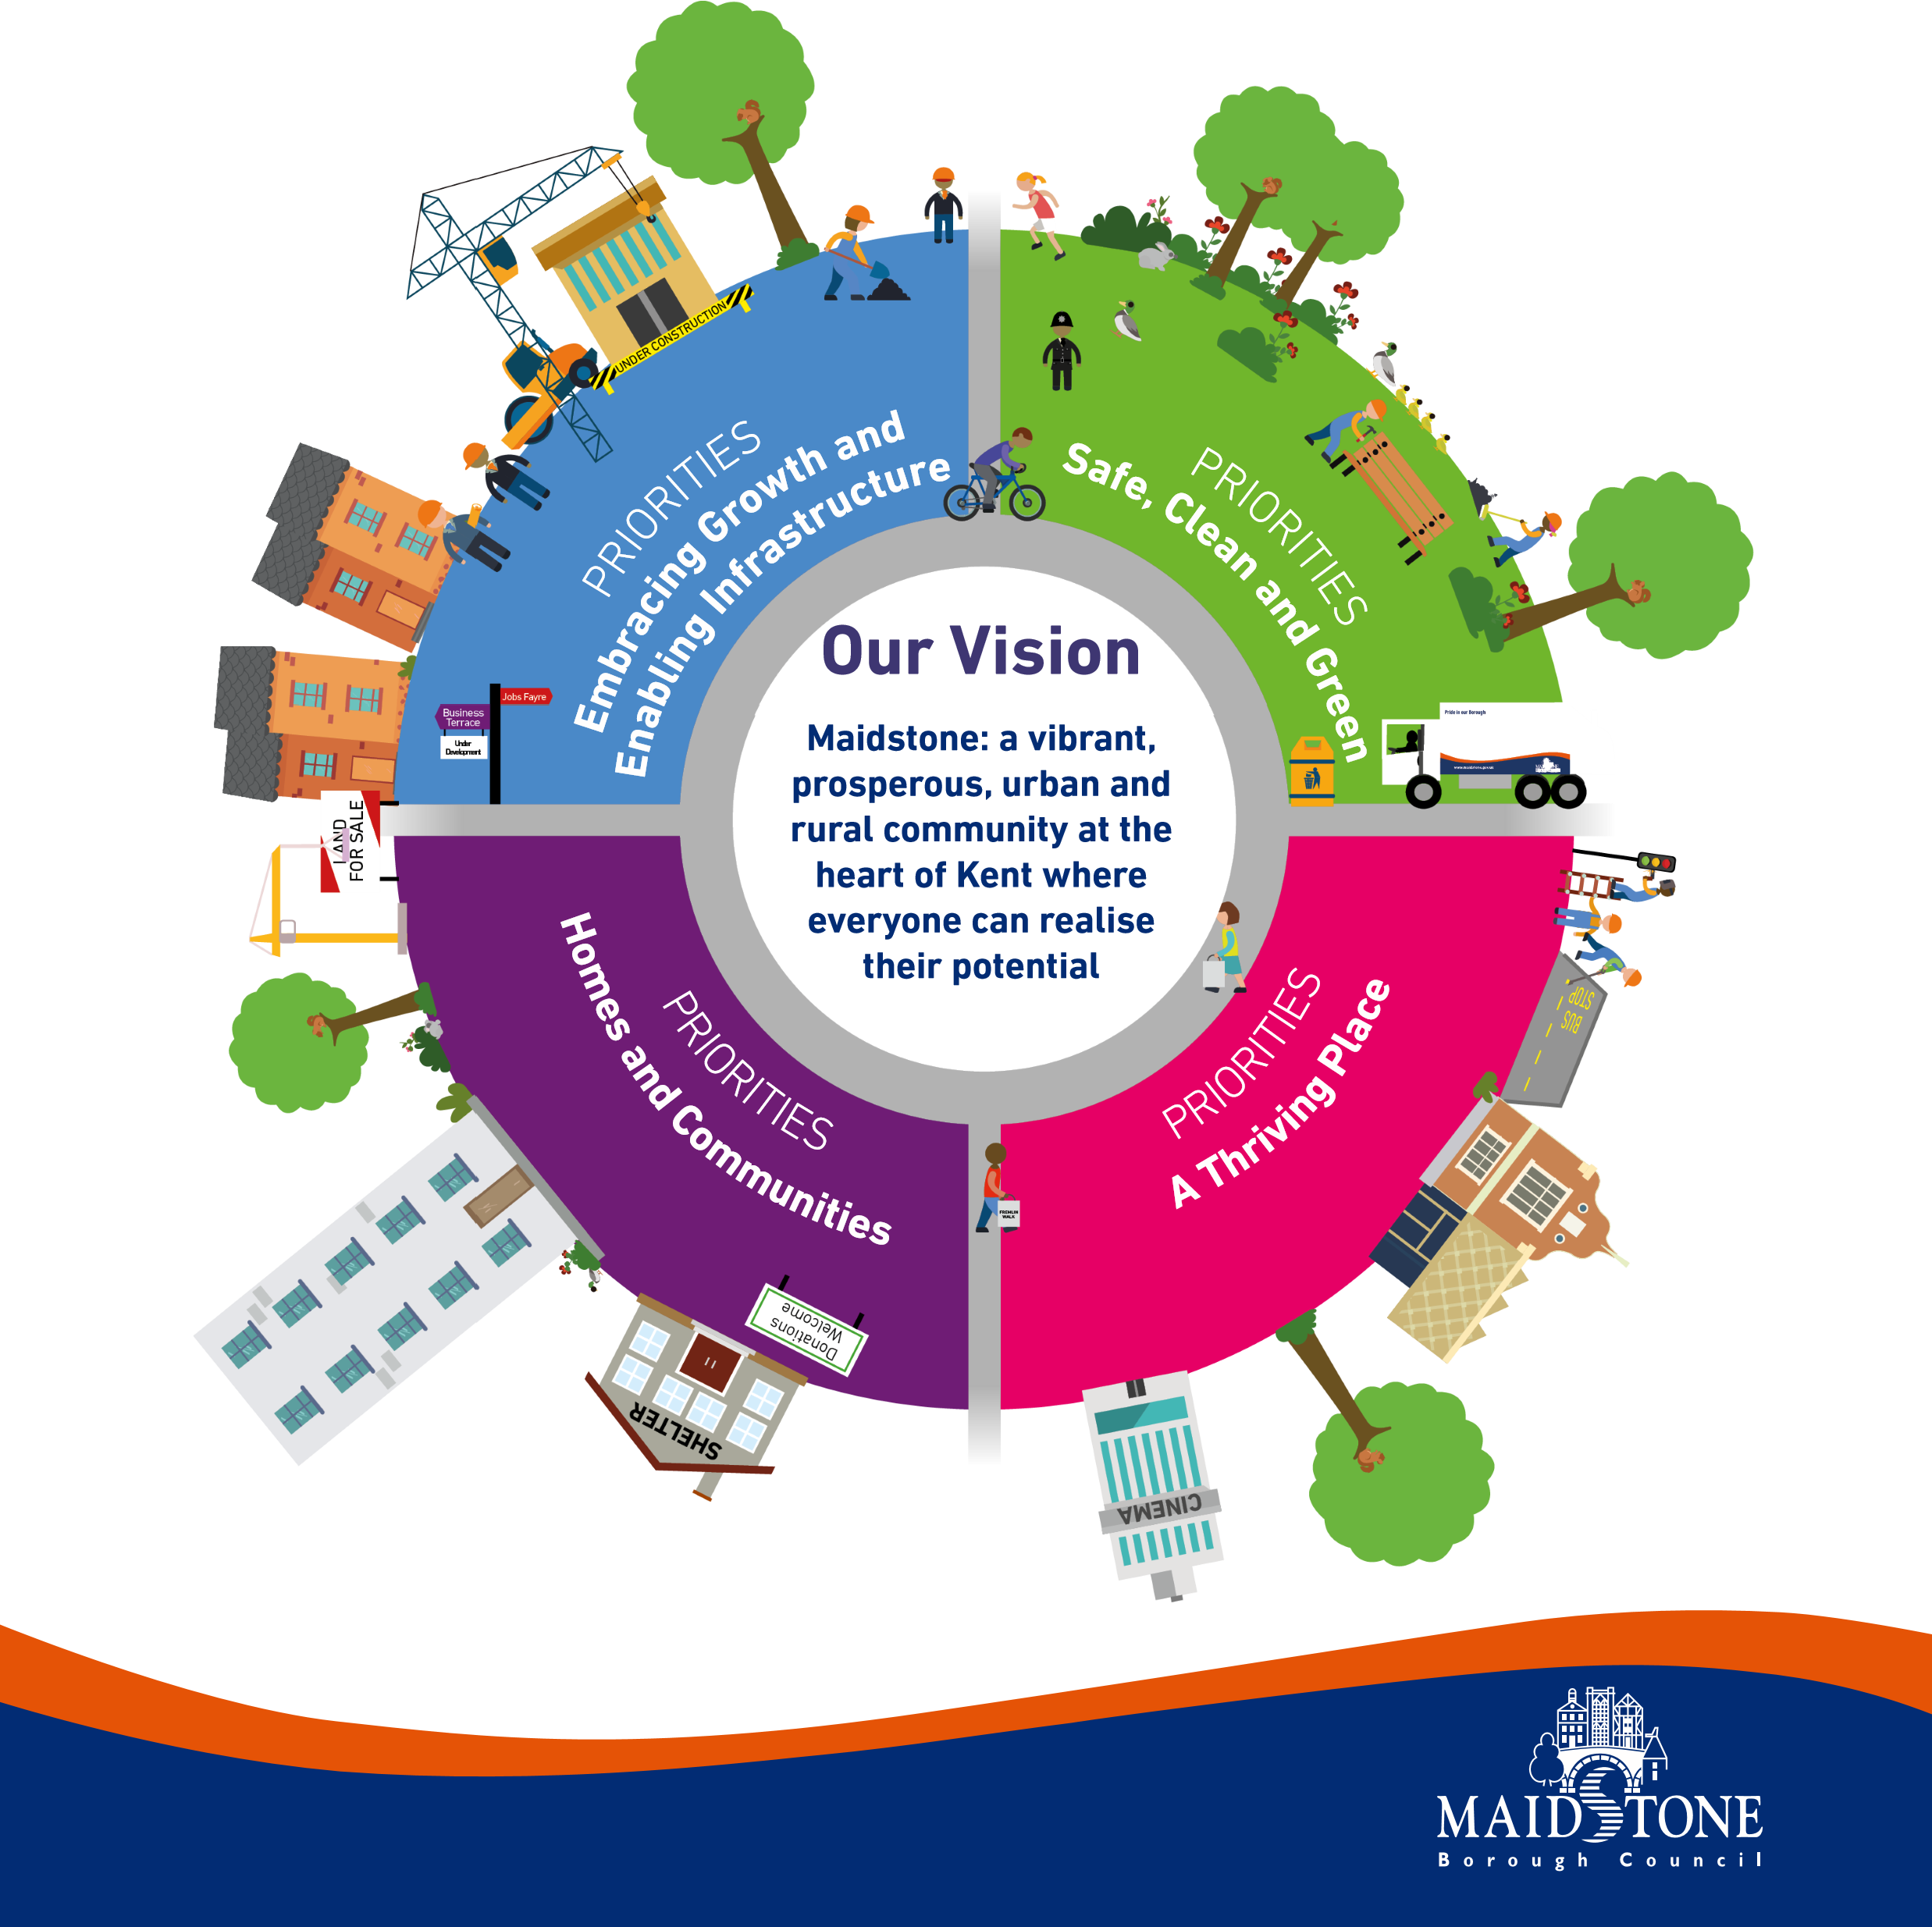
LOCAL PLAN REVIEW
Maidstone Borough Council
Regulation 19 Sustainability Appraisal – representation form

Introduction

What is this consultation?
The Maidstone Borough Council Local Plan Review: Regulation 19 submission document is accompanied by a consultation on the Sustainability Appraisal of the plan.
The Environmental Assessment of Plans and Programmes regulations (2004) requires that all Development Plan Documents are to be subject to a Sustainability Appraisal. This is reiterated in the National Planning Policy Framework.
The Sustainability Appraisal is required to consider and communicate the key sustainability issues and effects of emerging policies and any reasonable alternatives, and It is an iterative process which runs alongside the development of a plan and informs the ongoing decision-making process.
The document being consulted on is the Sustainability Appraisal of the Maidstone Local Plan Review Regulation 19 submission document. This consultation will open at 09.00 Friday 29th October 2021 and we need to receive your comments no later than 23.59 on Sunday 12th December 2021.

How can I comment of the Regulation 19 Submission Local Plan Review Consultation?
Any comments should be made using the Sustainability Appraisal Representation Form via the online consultation portal which can be found here: https://maidstone-consult.objective.co.uk/portal/
Alternatively, comments can be submitted using this form or by letter following the format of this form using the below methods.
- By email to ldf@maidstone.gov.uk
- By post to: Strategic Planning, Maidstone Borough Council, Maidstone House, King Street, Maidstone, ME15 6JQ
How will you use my data?
All consultation comments will be made publicly available on the consultation portal which can be found here: https://maidstone-consult.objective.co.uk/portal/ in due course. This is so that interested parties can view all the responses that have been received. Published information will include responses and responder name. All demographic and contact data will be removed. By submitting a representation, you are confirming that you understand that your consultation response will be published in full, together with your name. All data is processed in accordance with the Data Protection Act 2018. All representations will be processed in accordance with our privacy notice which can be found here: https://localplan.maidstone.gov.uk/home/privacy-notice

This form contains two parts
- Part 1: Personal details
- Part 2: Your representation(s)

Part 1: Personal Details

All responses must contain your full name and postal address in order for your response to be processed as part of this consultation.

Your name will be published alongside your representation on our consultation portal. All demographic and contact data will be removed. Please note, if you under 18 we will not publish your name, only your representation, please do specify your age if this is the case.
*If an agent is appointed, please complete the Title, Name and Organisation (where relevant) boxes below and complete the full contact details of the agent in the agent column.
 | Personal Details* | Agent Details (if applicable)
Title
First Name
Last Name
Job title (where relevant)
Organisation (where relevant)
Address Line 1
Address Line 2
Address Line 3
Address Line 4
Post Code
Email address

Maidstone Borough Council is committed to Equal Opportunities. The information you provide in this section will not be linked to any comments you make on consultation and you will not be linked to your name, address or other personal identifier. The information will be used for monitoring purposes only.

About you (Please tick)
Are you | Male
 | Female
 | Other – please state
Which of the following age group do you fall into? | 17 years and under
 | 18-24
 | 25-34
 | 35-44
 | 45-54
 | 55-64
 | 65-74
 | 75+
Which of the following best described your race or ethnicity? | White (English/Welsh/Scottish/Northern Irish/British/Irish/Gypsy/Irish Traveller)
 | Black/Black British (African/Caribbean)
 | Asian/Asian British (Indian/Pakistani/Bangladeshi/Chinese)
 | Mixed (White & Black Caribbean/White & Black African/White & Asian)
 | Other – please specify
Are your day-to-day activities limited because of a health problem or disability which has lasted, or is expected to last, at least 12 months? | Yes
 | No
 | Prefer not to say
Do you look after, or give any help or support to family members, friends, neighbours or others because of either long-term physical or mental ill-health/disability or problems with old age? | Yes, 1 to 19 hours
 | Yes, 20 to 49 hours
 | Yes, 50+ hours
 | No

Part 2: Your representation(s)

Please provide your comments on the Sustainability Appraisal in the box provided.
(Continue on a separate sheet/expand box if necessary)

